Addressing in Networking

Process Port Number = 16 bits

IPV4 Address = 32 bits

IPV6 Address= 128 bits

MAC Address = 48 bits

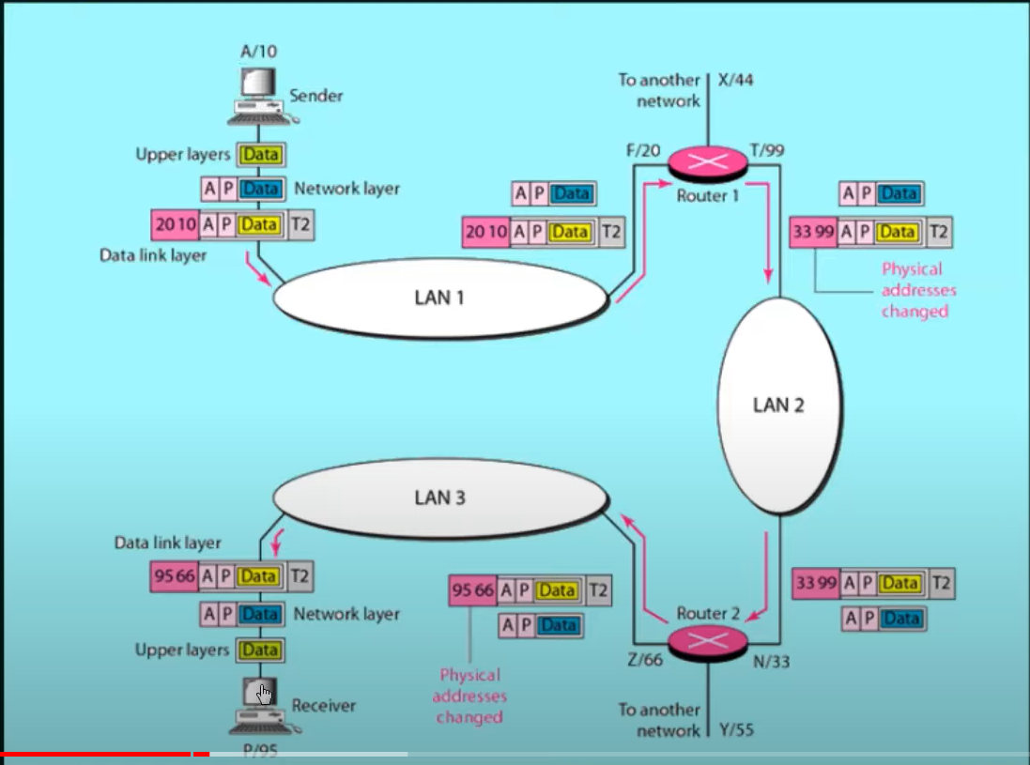

From default gateway (ex. First router), router takes the data, unpacks it, sees that the destination address is not equal to its IP address so it knows that the data is not meant for it. So it packs the data again with new source and destination MAC addresses.